# National University of Computer & Emerging Sciences, Karachi Artificial Intelligence-School of Computing



**Fall 2023, Lab Manual - 06**

|  |  |
| --- | --- |
| **Course Code (AI4002)** | **Course: Computer Vision Lab** |
| **Instructor(s):** | **Sohail Ahmed** |
| **Name:** | **Manahil Fatima Anwar** |
| **Roll Number:** | **20K-0134** |
| **Section:** | **BAI-7A** |

**Lab Tasks**

# Task 1: Thresholding-Based Segmentation

Scenario- You have a grayscale medical X-ray image of a bone fracture. The area of interest (the fracture) is significantly darker than the surrounding bone. Perform thresholding-based segmentation to isolate the fracture.

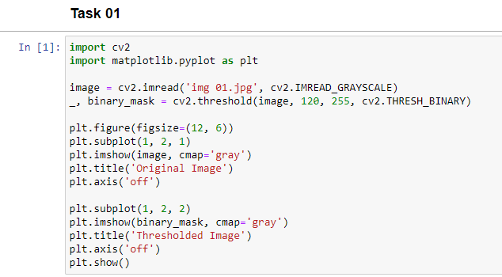

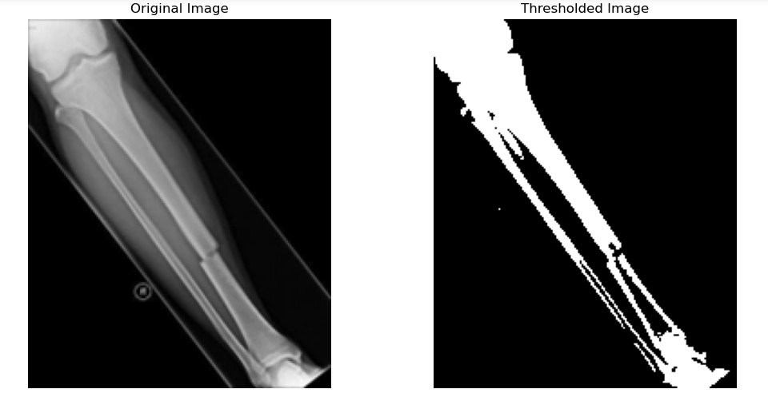

# Task 2: Region Growing Intensity-Based Segmentation

Scenario- You have a microscopic image of cells. Choose a seed point in one of the cells, and perform region growing- based segmentation to identify and separate that cell from the rest.

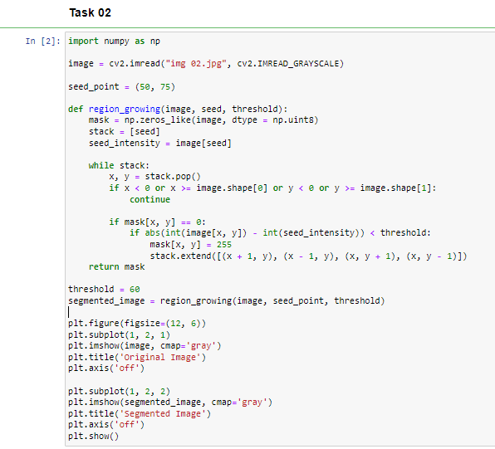

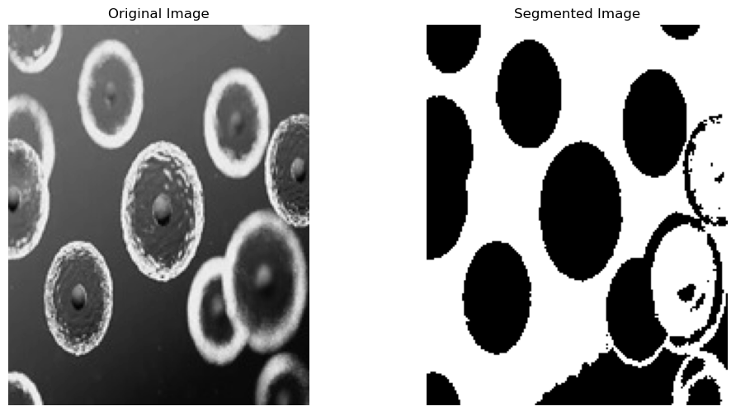

# Task 3: Watershed Segmentation

Scenario- You have an image of overlapping coins on a table. Perform watershed segmentation to separate and count the individual coins.

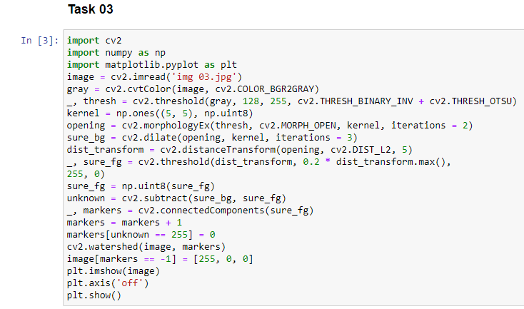

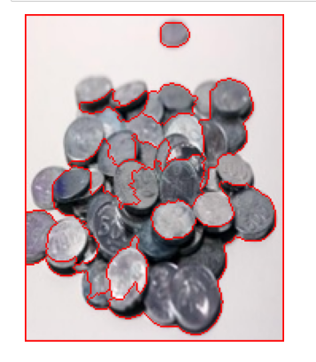

# Task 4: Cluster-Based Segmentation

Scenario- You have an image of colorful flowers in a garden. Perform cluster-based segmentation to separate different types of flowers based on color.

